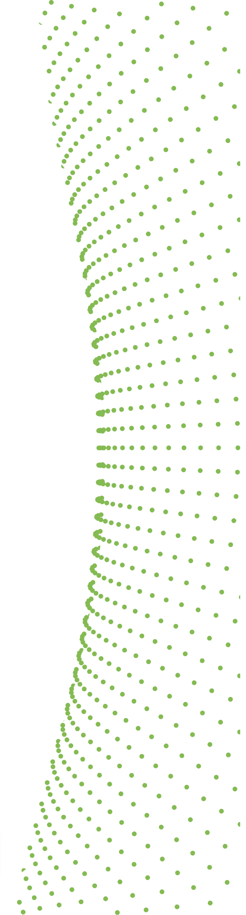
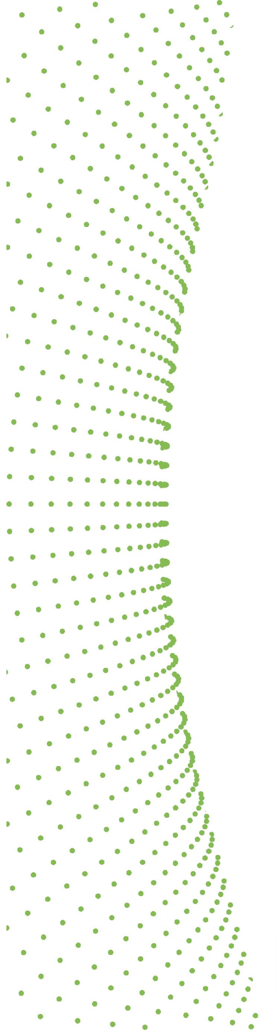
Second DIVA Open Call

DECLARATION OF HONOUR

I, the undersigned: first name, last name

Legal representant of the following entity:
Full official name of the SME
Legal form of the SME
Full official address
VAT registration number

I hereby certify that:

The information provided in the DIVA applicant form for the DIVA call is correct and complete
The information concerning the legal status given in the DIVA applicant form is correct
My organisation commits to comply with all the eligibility criteria, as defined in the DIVA guide for applicants
My organisation:
- is committed to participate in the project
- has stable and sufficient resources to maintain project activities

My organisation is not in one of the following situations which would exclude it from receiving DIVA grant:
- Is no bankrupt or being wound up, is not having affairs administrated by the courts, has not entered into an arrangement with creditors, has not suspended business activities, is not the subject of proceedings concerning those matters or is not any analogous situation arising from a similar procedure provided for in national legislation or regulations;
- Is in compliance with its obligation relating to the payment of social security contributions and the payment of taxes, in accordance with the legal provisions of the country in which it is established
- Is not subject to a conflict of interest in connection with the grant
I will inform the DIVA team of any other grant applications or grants from the EU budget related to this project.

Signature
First Name
Last Name
Position
Date

