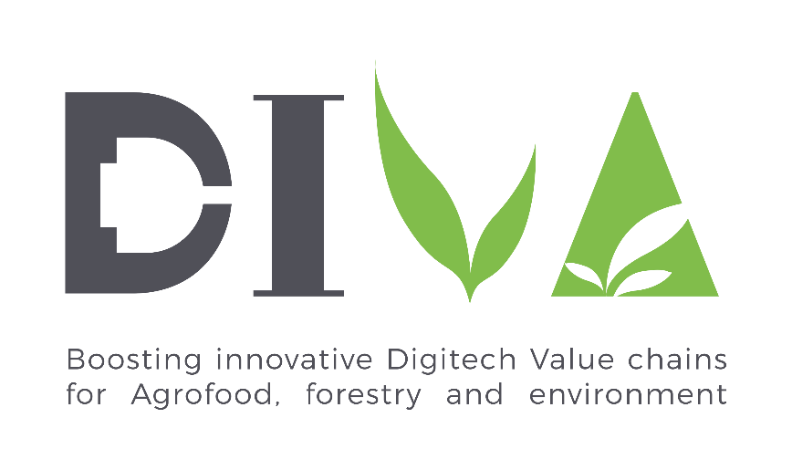

GRANT AGREEMENT N. 777890
Second DIVA Open Call for proposals
APPLICATION FORM
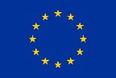
This project has received funding from the European Union’s Horizon 2020 research and innovation programme under grant agreement No 777890

Table of Contents

1 Administrative Form 4
2 Description of Work 15
3 Annex documents 18

Please follow the structure of this template to prepare your proposal, in order to ensure the good comprehension of your work to evaluators and make them able to assess your proposal with the impartial evaluation criteria.
All the information contained in the Administrative Form will be completed online on the DIVA platform.

The Description of Work document mustn’t exceed 10 pages. Minimum font size is 11. All proposal’s documents, data and information received from each applicant are treated as confidential. Confidentiality rules are respected along the whole span of the project.
The Description of Work will be uploaded as a PDF on the DIVA platform.

- Administrative Form
General information of the proposal
Proposal title:
Proposal acronym:
Voucher applied: X, required in one of the 4 main boxes

Business or Technology Maturation

Demonstration – Small scale

Demonstration – Large scale

Internationalization
Project starting date: later or the same day than call closing day
Project ending date: MAXIMUM 8 months and ending, at the latest, the 31st of December 2020. It’s an eligibility criteria.

DIVA Issues
Resource efficiency

Water and soil monitoring

Crop monitoring and planning

Risk assessment

Genetic engineering and phenotyping

Process monitoring and optimization

Smart packaging

Recycling and reverse logistics

e-business, e-platforms for marketing and commercialization

Smart tracking, smart logistics

Interaction with clients and end-users through demonstration and are showrooms

Food safety

Education and training

Data property and security

Knowledge and information

Are you answering a DIVA Challenge?
Yes,

If yes, title of the challenge
No

Have you already received a DIVA Voucher?
Yes,

If yes, which type of instrument?
Maturation

Small-scale Demonstration

Large-scale Demonstration

Internationalization

Value chain steps
Ecological sustainability and conservation of ecosystem services

Sustainable production
Advanced manufacturing

Transport chain

Service innovation and marketing

Social sustainability

Business trends
Data Economy

Digital Economy

Circular Economy

On Demand Economy

Sustainable Intensification

Sharing Economy

Digital technologies
Data analytics and big data

Blockchain

Robotics

Sensors

IOT

DSS

AI & Machine learning

Digital market place & platform

For Demonstration projects, are you testing your solution in a DIVA demonstration facility?
Yes,

If yes, name of the Demo site.

No

Non-confidential Abstract (1000 characters maximum) it doesn’t allow more than 1000 characters (stop writing beyond 1000 characters)

Type of proposal X is required in one of the 2 boxes
q Individual

Collaborative

List of participants
 | Role | SME legal name | Country
1 | Leader
2 | Partner
3 | Partner
4 | Partner
5 | Partner

Not valid: country of the leader different from Fr, Gr, It, Irl, Pt or Sp
Administrative data of SME(s)

LEADER SME
Legal Name:
Address: street, town, postcode, country, webpage
Legal status: eligibility criteria
Is the company a SME?
Yes

No

VAT number:
Creation date:
Main activity: at least one word required

Legal person
Title:
Sex: male female

First name:
Last name:
Position in SME:
Address:
E-mail:
Phone:

Person in charge of the proposal
Title:
Sex: male female

First name:
Last name:
Position in SME:
E-mail:
Phone:

SME status check
Number of employed persons: number required
2018 Turnover (€): number required
2018 EBITDA (€): Optional
Shareholders: information required
Legal Name | VAT number | %
Payment data
Bank Name:
Bank address:
Bank Account:
Did the SME received any grant from the EU budget for this project

Yes,

If yes, from which EU program? How much?

No

Did the SME applied or aim to apply for another grant from the EU budget for this project
Yes,

If yes, from which EU program? How much?

No

SME 2 the same as before
Legal Name:
Address: street, town, postcode, country, webpage
Legal status:
VAT number:
Creation date:
Main activity:

Person in charge of the proposal
Title:

Sex: male female
First name:
Last name:
Position in SME:
E-mail:
Phone:

SME status check
Legal status: eligibility criteria
Is the company a SME?
Yes

No

Number of employed persons:
2018: Turnover (€):
2018: EBITDA(€):

Shareholders:
Legal Name | VAT number | %

SME 3 the same as before
Legal Name:
Address: street, town, postcode, country, webpage
Legal status:
VAT number:
Creation date:
Main activity:

Person in charge of the proposal
Title:

Sex: male female
First name:
Last name:
Position in SME:
E-mail:
Phone:

SME status check
Legal status: eligibility criteria
Is the company a SME?
Yes

No

Number of employed persons:
2018 Turnover (€):
2018 EBITDA (€):
Shareholders:
Legal Name | VAT number | %

SME 4 the same as before
Legal Name:
Address: street, town, postcode, country, webpage
Legal status:
VAT number:
Creation date:
Main activity:

Person in charge of the proposal
Title:

Sex: male female
First name:
Last name:
Position in SME:
E-mail:
Phone:

SME status check
Legal status: eligibility criteria
Is the company a SME?
Yes

No

Number of employed persons:
2018 Turnover (€):
2018 EBITDA (€):
Shareholders:
Legal Name | VAT number | %

SME 5 the same as before
Legal Name:
Address: street, town, postcode, country, webpage
Legal status:
VAT number:
Creation date:
Main activity:

Person in charge of the proposal
Title:
Sex: male female

First name:
Last name:
Position in SME:
E-mail:
Phone:

SME status check
Legal status: eligibility criteria
Is the company a SME?
Yes

No

Number of employed persons:
2018 Turnover (€):
2018 EBITDA (€):
Shareholders:
Legal Name | VAT number | %

- Description of Work

Excellence
Objectives
Describe the origin of the business idea and market needs/demands that support this idea.
Describe the objectives of the overall innovation project and the subsequently expected outcome. Industrial, economic, social, sectoral problem to be solved and business opportunity addressed.
Quality of the proposed solution
Describe the proposed solution (product, service, process), its highlights and advantages compared to existing solutions.
Describe the technical feasibility of the proposed solution.
Describe how the proposal solution is doable within the timeframe of the project.
Innovation
Describe the innovativeness of the proposed solution and how it will solve the identified problem through the business idea implementation.
Describe the positioning of the business innovation project, where it is situated in the spectrum from “idea to application” or from “lab to market”.
Describe the current stage of innovation of the technology, referring to the Technology Readiness Levels definition (see https://ec.europa.eu/research/participants/data/ref/h2020/other/wp/2016_2017/annexes/h2020-wp1617-annex-g-trl_en.pdf)

Impact
Business model
Describe the potential business model and how it fits with the SME / consortium strategy.
Describe user needs and potential users (mention Diva challenge addressed if relevant).
Describe the type of market which the project addresses: size, maturity, trends, barriers, geographical zone
Describe the main competitors and competitive existing solutions.
Value chain
How can the proposed solution provide more added value in the whole focused value chain.
How can the proposed solution contribute to creation of an innovative value chain.
Cross sectoral features and cross-border ambition
Description of how the project contributes to create a new value chain with cross-sectoral features and a cross-border ambition.
Diva thematic alignment
Describe how the proposed solution is in line with DIVA trends and digitech.

Implementation
Work plan
Describe the general work plan of the project, work packages and corresponding deliverables: work to be done, role of each SME (when applicable) and methodology to be deployed to achieve objectives of the proposal (Mention DIVA demonstration sites if relevant.).
Work package title
Timeline
Objectives
Description of work
Deliverables

Describe the timeline of the project.
Capacities
Give a general description of (each) SME(s) main activity and achievements.
Describe the complementarity of partners in the consortium (if applicable) and how its profile matches tasks in the proposal.
Describe technical and business experience of each SME person involved in the proposal (Curriculum Vitae) and their role into the proposal.
Describe management capacity to lead team /consortium (if applicable).
Resources to be committed
Describe availability of resources required (facilities, personnel, networks etc..) to develop project activities.
Describe the overall cost structure of the proposal. For subcontracting, describe activities to be developed by subcontractors and their capacities.
Provisional budget should be equivalent or superior of the amount of the voucher.
Fulfill the following budget chart:
Cost (€) | Direct personal | Subcontract | Other direct costs | Indirect costs | Total
Leader (SME 1)
SME 2
SME 3
SME 4
..
Total

- Annex documents
Copy of the profit and loss account and balance sheet for the last three years for which accounts have been closed.

CV of SME(s) persons involved in the proposal
A brief CV of SME(s) staff involved in the proposal will be provided in PDF format.

Subcontractors agreement (if applicable)
Subcontractor agreement will be provided describing tasks, timeline, and explaining budget.

Consortium agreement (if applicable)
For a collaborative project, draft of consortium agreement will be provided, describing partners role and responsibility and budget distribution.

Declaration of honor
A declaration of honor, signed by beneficiary SME, will be provided. The following template can be used:

DECLARATION OF HONOUR

I, the undersigned: first name, last name

Legal representative of the following entity:
Full official name of the SME
Legal form of the SME
Full official address
VAT registration number

I hereby certify that:

The information provided in the DIVA applicant form for the DIVA call is correct and complete
The information concerning the legal status given in the DIVA applicant form is correct
My organisation commits to comply with all the eligibility criteria, as defined in the DIVA guide for applicants
My organisation:
- is committed to participate in the project
- has stable and sufficient resources to maintain project activities

My organisation is not in one of the following situations which would exclude it from receiving DIVA grant:
- Is not bankrupt or being wound up, is not having affairs administrated by the courts, has not entered into an arrangement with creditors, has not suspended business activities, is not the subject of proceedings concerning those matters or is not any analogous situation arising from a similar procedure provided for in national legislation or regulations;
- Is in compliance with its obligation relating to the payment of social security contributions and the payment of taxes, in accordance with the legal provisions of the country in which it is established
- Is not subject to a conflict of interest in connection with the grant
I will inform the DIVA team of any other grant applications or grants from the EU budget related to this project.

Signature
First Name
Last Name
Position
Date

The list of Challenges can be found on DIVA website: https://www.projectdiva.eu/challenges-list/
The list of Business Trends can be found on DIVA website: https://www.projectdiva.eu/diva-trends-map/
The details of Digital technologies can be found on the DIVA website: https://www.projectdiva.eu/diva-digitech-value-chain/
The list of Demonstration facilities can be found on DIVA website: https://www.projectdiva.eu/demonstration-facilities/
For internationalization proposal, applicant has to explain the targeted country where it wants to deploy its technology.
DIVA priority thematics can be consulted in DIVA’s website in the Digital Trends Map and Framework.
For demonstration proposal, applicant has to explain the demonstration activities and what is expected in terms of results.
List of DIVA demonstration sites can be found on DIVA website : https://www.projectdiva.eu/demonstration-facilities/

